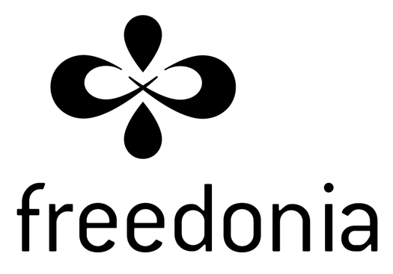
2023 Funding Application
Please send your completed application to: intake@freedonia.ca
Section A: Group Information
Title of Project
Name of Group
Amount Requested
Are you requesting 3-year funding? | ◻ yes ◻ no
Names of core members/organizers
Phone number for group
Email address for group
Website
Social media link(s) for group
Who should we contact about this application?
Name
Email Address
Phone number

What are the goals or purpose of this group/organization?

Sponsoring Organization (if applicable)

Is the Applicant group part of a larger organization or sponsored by another organization?
◻ yes ◻ no

If yes, please provide the following information about the Sponsoring Organization:
Name
Email Address
Phone number
Website
Primary Contact Person

Section B: Summary of Project
Name or Title of project:

One paragraph description or point form about the project:

Section C: Detailed Project Information

(Take as little or as much space as you need. A paragraph to answer each question is usually sufficient. Bullet points are also fine. You are welcome to be informal and please use plain language.)

- What do you want to do? What will this funding help you accomplish?

- Why is your project needed right now in your community? Why does this matter?

- Freedonia wants to support projects where communities lead their own struggles or where there are established bonds of solidarity. Which communities, local groups, and organizers will be involved in your project and how?

- How are you accountable to the communities you are working with? How are you accountable to those most affected by the issue(s)?

- What do you hope will happen as a result of your project and will you reflect on the results?

- Where will the project take place?

- What role does your project play in broader struggles or movements? What will this project contribute to broader struggles or movements?

- Why are you the right people to do this project? Please describe any specific resources, skills, or experiences you have, which will help you carry out this project.

- How does your project help to further Freedonia’s Mission Statement? Please explain how does your project helps to uplift the anti-capitalist and anti-authoritarian values of Freedonia?

- How do you organize yourself along the principles of collective action and horizontal relationships? How do you share power within your group?

- Please provide details on project activities. Include timelines that will allow you to chart your group’s progress. Please attach additional pages if necessary.

Activity | Description | Date(s)

Section D: Project Budget Requirements

Please provide a detailed budget for the project. This may be submitted as an attachment at the bottom of this form.

Budget details:
Category | Details | Amount
Example: Transportation | 20 bus tickets x 2 meetings @ $3 | $120
Example: Honoraria | Elders, meeting facilitation, etc.
Example: Food | Meals for 20 people x 2 meetings | $200 (in kind donation)
Total cost of the project:
Amount requested from Freedonia (Maximum $5000):

What other sources of funding do you have? What will it be used for?

Has your group received funding from Freedonia in the past? If yes, please list below:
Year | Project

Section E: Additional Information
Please include any other information that will help us assess your application.

